PROJECT NAME

BASELINE PROGRAMME REV P500-BL-00-0

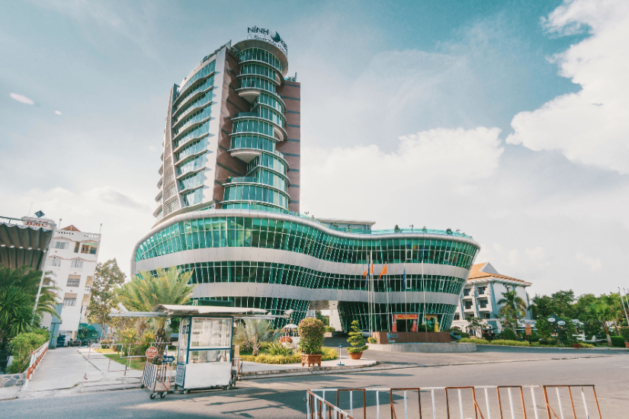

EMPLOYER | MAIN CONTRACTOR | ENGINEER
TABLE OF CONTENTS

SN | DESCRIPTION
1 | PROJECT CONTRACT DATA
2 | LOGISTICS PLAN
3 | PROGRAMME DATA
4 | CALENDAR
5 | PROGRAMME ASSUMPTION
6 | PROGRAM ORGANIZING
7 | KEY TO ACTIVITY CODE, ACTIVITY ID STRUCTURE
8 | WBS DICTIONARY
9 | SUMMARY CL.14 PROGRAM
10 | DETAILED CL.14 PROGRAM
11 | CRITICAL PATH ACTIVITIES
12 | PRODUCTIVITY ASSUPSSIONS
13 | CASH FLOW CHARTS
14 | MANPOWER HISTOGRAM

PROJECT CONTRACT DATA

PROJECT SUMMARY

 | GENERAL
 | PROJECT | : | Project name
 | LOCATION | :
 | CLIENT | :
 | CONSULTANTS | :
 | CONTRACTOR | :
 | BUILDING DETAILS
 | NO OF FLOORS | : | G+35 F+R
 | CONTRACTUAL DETAILS
 | CONTRACT VALUE | : | xxxxx | USD
 | PROJECT START DATE | : | xxxx
 | PROJECT COMPLETION DATE | : | xxxx
 | PROJECT DURATION | : | xxx | DAYS

LOGISTICS PLAN

SITE LOGISTICS

Tower Cranes

Two Tower Cranes will be installed for The Project at the designated location. Construction Manager will assess the best setup with respect to carnage depending upon the time for execution of the civil works. The Construction Manager, will co-ordinate the installation and demobilization schedule of the cranes. This will be in accordance with the detailed construction programmes and with the approval of the Project Manager.

Hoists

Two Passenger & Material lifting Hoists for the project will be installed at 4th Floor at the designated location. The Construction Manager, in consultation with the Construction Manager , will co-ordinate the installation and dismantling schedule of the Hoists. This will be in accordance with the detailed construction programmes and with the approval of the Projects Manager.

Concrete Pump
Concrete will be supplied from the approved Ready Mix Concrete Batching Plant. Regarding mix design, prior approval will be taken from the consultant.

Transit Mixer trucks and Mobile Concrete Pumps will be used From Foundations to 3rd podium floor. Each pump will have enough capacity to deliver concrete to the farther point in building. Number of concreting pumps is determined in consideration of pouring times to meet Baseline programmed requirements.

Concrete static pump with pipeline of required capacity and height will be used from 3rd floor to upper roof floor. Two placing booms will be installed within the slab of tower area to perform casting the concrete of the Slabs, Beams and the vertical structural members (Columns & Walls). Static pumps which will be allocated at a suitable location for this purpose as shown in the attached layout and will be connected to placing booms through static discharge pipes. Concrete will be discharged in pour point in uniform layers and vibrated by immersion-type needle vibrators.

PROGRAMME DATA

CALENDAR
Calendar Holidays 2019-2020-2021
Calendar (Main Contractor Corporate Calendar) - 6 days working week
Work Week Calendar
Project calendar was considering 6 day working week 10 hrs per day as follows:

Sunday Working
Monday Working
Tuesday Working
Wednesday Working
Thursday Working
Friday Nonworking
Saturday Working
Yearly national holidays in UAE

Project calendar was considered the national holidays In UAE as follows:

2019 |  | 2020
New Years Day | January 1 | New Years Day | January 1
Israa & Miaraj Night | May 5 | Israa & Miaraj Night | April 22
Eid Al Fitr | July 6 | Eid Al Fitr | June 27
Eid Al Fitr | July 7 | Eid Al Fitr | June 28
Arafat(Haj Day) | September 10 | Arafat(Haj Day) | August 29
Eid Al Adha | September 11 | Eid Al Adha | August 30
Eid Al Adha | September 12 | Eid Al Adha | August 31
Hijri New Years | October 2 | Hijri New Years | September 22
UAE National Day | December 2
UAE National Day | December 03
Prophet Mohamed’s Birthday | December 11

Programme Assumption
- Programme has developed by CPM Method with Primavera P6 ver 21 Software.

- Programme Scheduling Method Retain to Logic

- Total Float Calculation using Finish dates.

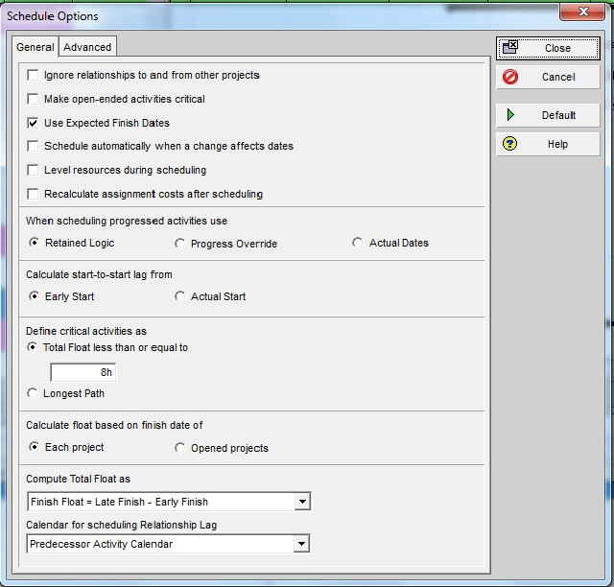

Construction Program Brief:

The program has been prepared considering the proper work breakdown structure and the activities have been distributed in proper details as mentioned below.
The program covers in proper details the following:
- Contract Particulars, Permits, and NOC aspects.
- Mobilization and related items.
- Subcontractor’s submittal/approval.
- Material submittal and approval flow.
- Shop drawings submittal and approval flow.
- Procurement flow.
- Construction activities
- Handing over activities including authority related ones, testing and commissioning and final handing over.

PROGRAM ORGANIZING:

For defining scope and to achieve proper level of detail in activities, and for program organization both WBS and activity code methods have been implemented. The detailed activity code has been attached along with this submittal for information. The program is detailed out up to such a level so that it is easy to monitor the major activities that will have dependencies on other activities

ACTIVITY ID STRUCTURE

ACTIVITY ID
Activity ID Structure was designed in a flexible way allowing for ID to deform according to the area of application for the best program integration.
WBS 1st Level (2 Digits)
WBS 2nd Level (3 Digits)
WBS 3rd Level (2 Digits)

Initials |  |  | WBS Description | Example
 |  |  | WBS Description | Activity ID | Activity Description
GR |  |  | General
 | KDS |  | Key Date (Milestones) | GRKDS1000 | End Project Milestone
AT |  |  | Authorities
 | DCD |  | Dubai Civil Defense
 | DEW |  | DEWA
 | TAR |  | Tarakhes | ATDCD100 | Civil Defense Final Inspection
 | TEC |  | TECOM
 | 0DM |  | Dubai Municipality
EN |  |  | Engineering
 | 0PS |  | Provisional Sum | ENPSI100 | Nomination for Lift Sub-Contractor
 | 0PC |  | Prime Cost
 | 0SD |  | Shop Drawings
 |  | PP | Preparation and Submission | EN0SDPP10 | Shop Drawings for Cladding
 |  | RA | Review and Approval
 | PRC |  | Procurement
 |  | DM | Domestic Items
 |  | LL | Long Lead Items | ENPRCLL10 | Delivery of Lift
 |  | PC | Prime Cost Items
 |  | PS | Provisional Sum
CN |  |  | Construction
 | SUB |  | Sub-Structure
 | 0B# |  | Basement Number
 | 0GF |  | Ground Floor
 | 0F# |  | Floor Number
 | ROF |  | Roof
 |  | CW | Concrete Works
 |  | FN | Finishes Works | CNF2FN10 | Ceramic for 2nd Floor
 |  | MP | MEP Works
 | FCW |  | Façade Works
 |  | E# | Elevation Number
 | SPE |  | Specialties
 |  | CS | Conveying System | CNSPCS10 | Lift Equipment Installation
 |  | GC | Garbage Chute
 | EXW |  | External Works
 |  | SP | Swimming Pool
 |  | LS | Landscape
TS |  |  | Testing and Commissioning
HO |  |  | Handing Over
 | DOC |  | Documentations
 |  | CV | Civil Works | HODCCV10 | Submit As-Build Drawings
 |  | MP | MEP Works

WBS DICTIONARY

Referring to Attachment 1

SUMMARY BASELINE PROGRAM

Referring to Attachment 1

DETAILED BASELINE PROGRAM

Referring to Attachment 1

CRITICAL PATH ACTIVITIES

PRODUCTIVITY ASSUMPSSION

Cash Flow Charts

Manpower Histogram

